**SysEng 6104 Project Task III**

**Inputs for Architecture Generation: Functional Architecture**

1. Based on your answer to question two and three in Project Task II define 5 fuzzy terms that can be used in assessing an overall system architecture. Define each of fuzzy term with 20-30 words. You can use the system selected to explain your definitions
2. Use OPM representation discussed in the text and class to build functional architecture for your system that covers at least three levels in internal functions like the example given below (Note the example given below is just a tree representation it does not use OPM). Since three levels are required you need provide sub-sub-functions for the sub functions provided in the figure. In your functional architecture you need to identify functions forms and operands.   
   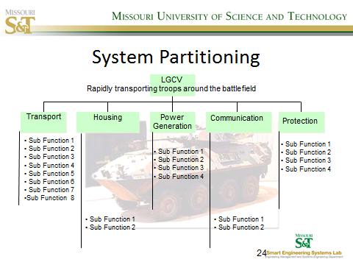

Define the following terms for your system with 50 words for each.

MOE – Measure of Effectiveness

(Operational/User Requirement)

MOP – Measure of Performance

(System Requirements)

TPM – Technical Performance Measure